Introduction to Team Charter
The development of a team charter helps the members of the team to:
- Agree a communication plan for their collaboration on the project(done!)
- Outline how the team plan to utilise technology for their communications(done!)
- Clarify roles within the team
- Discuss and agree how the team plan to operate in order to achieve the deliverables(done!)
Team Operating Guidelines
The team charter helps the team to outline their ‘modus operandi’ for the project – how the team will operate in order to achieve the final deliverables. Research has shown that high performing teams follow these guidelines for Online Teams:
- Give regular recognition to fellow team members for their contributions
- Always keep agreements on follow-up, contributions, and giving feedback
- Understand it is a team effort: Lead by persuasion, not by force
- Join online meetings on time and actively participate. Have your video on.
- Hold yourself and the team accountable for meeting minutes, action items, and call for agenda items
- Communicate clearly and on time
- Take time to get to know each other, especially when forming the team
- Rotate leadership tasks among the team members
- Accept failures and issues as they are signs of progress
- Keep perspective and focus on final deliverables from the beginning
This template is provided to help the team define their team charter and this includes a recommended list of questions to prompt discussion between team members when developing this important document.

Team Charter Example:

Team: Starneo |  | Team Member names:  Salman Alsamiri, Nicolas Condrea, Rianlee Gabriel Pineda , Antony Morris, Xie Xin.
# | Article | Why is this important? | Describe/Explain:  (** To be agreed by the Team)
1 | What are your team values? | Values are the qualities that are important to us.  Values guide our choices in how we work together. | Communication by keeping each other in the know  , cooperation to ensure each other does their part  , commitment to try to deliver the work as promised  ,and integrity to be honest to each other and to our work.
2 | What is your team logo? | Great teams have an identity, this is your chance to create one! | 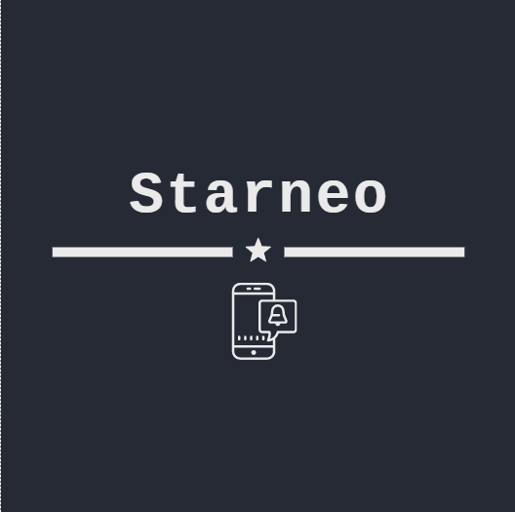
3 | How would you sum up your team? | What makes your team different, you can create a team motto. | We got the skills to pay the bills.
 | Communication
4 | What technologies will you use to share ideas and store your work? Google Drive / Dropbox / Trello / Slack / Other? | Having an organisational structure for your team will save time and reduce stress! | Microsoft Teams, Trello, and/or discord will be used for communication. as we will be mainly using 1, but the other two as a backup form of communication.  Git hub, one drive and/or google drive  For sharing files,  we will be using git hub, but as being cautious we will keep in mind having a shared drive and forward emails.
5 | How will you alert your group to new versions of documents or when you have completed a task? | Having a system to alert your team mates when you have made your changes makes things easier and faster for the whole team. | Git hub, Trello,MicrosoftTeams, and google drive will be sending notification when an update or change occur and will be communicating about any major changes.
6 | How will you make decisions? | In cases of disagreement it is better to decide how you will make decisions from the start of a project. | Put it to vote, look at pros and cons of the decision, do a straw poll.
 | Team Roles
7 | Identify the key Team Roles & Responsibilities.  Who is assigned to these? | You will require leadership in various roles. Teams perform best when these are clearly defined. | Coordinator(Salman), Designer(Xin), Planner(Nicolas), coder(Antony), Tester(Rianlee) and Documenter(All).
 | Meetings
8 | When will you hold your meetings? | Agreeing a regular meeting is probably the most important thing you can do to have a great team-working experience. | Tuesday at around 12pm , Thursday at around 1pm,and Friday an hour about 12pm and an hour at about 4pm.
9 | What happens before each meeting? (How will you arrange a meeting? How will you gather agenda items? | Organised teams are not only more successful but have much higher levels of enjoyment and satisfaction. | Prepare plans, questions, and check resources.
10 | Who will chair the meeting? | It is important to have someone who makes sure the meeting keeps to time and all agenda items are covered. This can be rotated. | The Coordinator: Salman AlSamiri
11 | Who will take notes? | Well taken notes are invaluable to a team, especially if someone cannot attend a meeting. | The Planner: Nicolas Condrea
12 | What happens during a meeting? | Out of respect, all participants should be both visually & audibly present. Having a set format saves time and makes it easier for the team. | Going to present plan, ideas, and goals we have and take in the response while communicating with the team and each other.
13 | What happens after a meeting? How will you send out tasks? | Organised teams are the most successful and the happiest! | Discuss what happened during the meeting and the response we got, plan what to do next and prepare for any eventuality.
14 | What if someone is late for a meeting? | It can be disruptive having to start a meeting several times, so decide how you want your meetings to go if not all members are there on time. | Try to consider the condition of the person, and if the time were not suitable, then we go and adjust the meeting time for everyone.
15 | What if someone cannot make a meeting? | If you cannot make a meeting let your team know – it is just good manners! | Send them the meeting notes and have one of the members of the team explain any query they might have.
 | Documents
16 | How will you name documents? | This is very important so everyone can find documents and know they are working from the latest version. | Add the week number to the end of the document name, with the team name and if possible, the goal of the week.
 | Attendance and Engagement
17 | What if someone is sick or has a holiday booked? | Absences from your team can be disruptive but are sometimes unavoidable. Keeping your team in the loop minimises that disruption. | For the absent person to alert the team about the absence and for how long.  For the team will try to split the work of the absent person and prepare notes for that person to help them catch up to the team.
18 | What if a team member is under-performing? | Occasionally a person’s participation on the programme can falter, you should decide as a team how you will deal with this. | Depending on the reason, we will try to help the person to preform better and try to split the work or exchange responsibilities, but if it came to worse will communicate with the lecturer who handles the team for their opinion on the matter.

Our Pledge
We have discussed and agreed to this charter and we are fully committed to keep all agreements made within. On this basis we are ready to proceed with online collaboration
(All team members must sign)
Signed:

Salman Alsamiri, Nicolas Condrea, Rianlee Gabriel Pineda , Antony Morris, Xie Xin

